CHATGPT 2025 PREDICTED SAMPLE EXAM PAPER 1
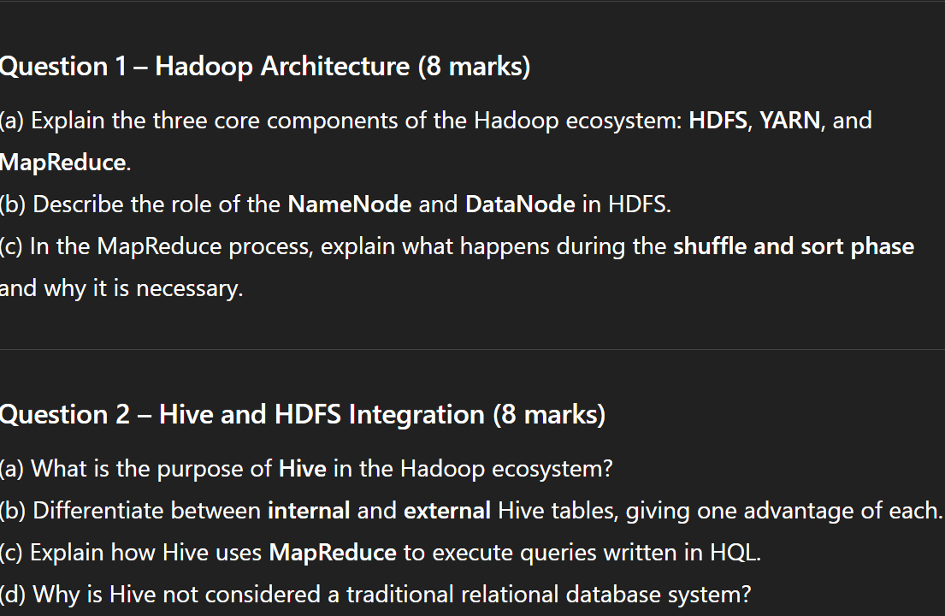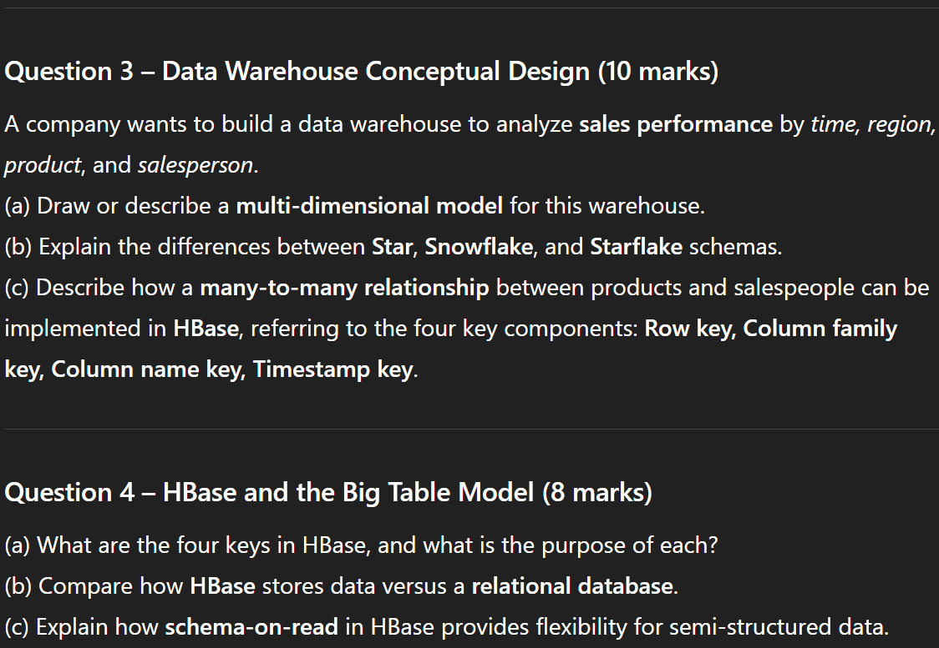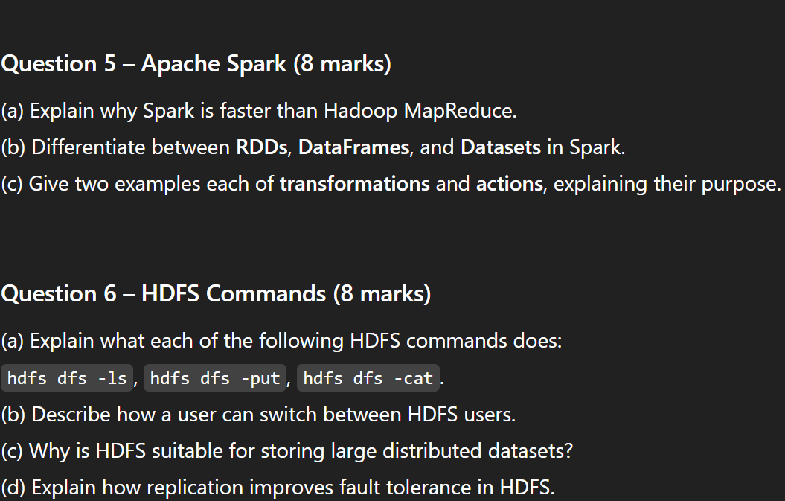

Section | Marks | Focus
Hadoop | 8 | Layers, components, phases
Hive | 8 | Purpose, table types, integration
Data Warehouse | 10 | Schema design, HBase mapping
HBase | 8 | 4 keys, structure, schema-on-read
Spark | 8 | RDD/DataFrame/Dataset, speed, actions
HDFS Commands | 8 | Basic commands, concepts

Question 1 – Hadoop Architecture (8 marks)
- Explain the three core components of the Hadoop ecosystem: HDFS, YARN, and MapReduce.
HDFS is Hadoop Distributed File System. It stores large datasets across clusters of commodity hardware. Provides fault tolerance through replication
YARN is Yet Another Resource Manager. Manages system resources and schedules tasks. Handles job allocation between nodes.
MapReduce is the data processing framework that splits tasks into map (parallel processing) and reduce (aggregation) phases.
(b) Describe the role of the NameNode and DataNode in HDFS.
NameNode: The master node, stores file system metadata (file names, block location, permission). Does not store actual data
DataNode: The worker node, stores actual data. They send periodic heartbeats and block reports to the NameNode.
(c) In the MapReduce process, explain what happens during the shuffle and sort phase and why it is necessary.
After mapping, shuffle redistributes intermediate key-value pairs to reducer based on their keys.
Sort arranges these pairs by key so that all values with the same key go to the same reducer.
This phase ensures correct grouping of data before reduction, which is essential for aggregation and join operations.

Question 2 – Hive and HDFS Integration (8 marks)
- What is the purpose of Hive in the Hadoop ecosystem?
Hive is a data warehouse tool built on top of Hadoop that allows users to query and analyze large datasets stored in HDFS using HQL (Hive Query Language). It converts these queries into mapreduce jobs automatically.
(b) Differentiate between internal and external Hive tables, giving one advantage of each.
Internal Table: Hive manages both schema and data--> Advantage is that it is easier to manage, data deletes when table is dropped.
External Table: Hive only manages schema, data stored externally in HDFS. --> Advantage is Data remains if table is dropped which is useful for shared data.

(c) Explain how Hive uses MapReduce to execute queries written in HQL.
Hive translates HQL queries into MapReduce jobs behind the scenes. Each SELECT, JOIN, GROUP BY is compiled into one or more MapReduce tasks that process data stored in HDFS.
(d) Why is Hive not considered a traditional relational database system?
Hive lacks row-level operations
It is schema on read, not schema on write
It runs on distributed storage (HDFS) and uses batch processing instead of transaction-based operations.

Question 3 – Data Warehouse Conceptual Design (10 marks)
A company wants to build a data warehouse to analyze sales performance by time, region, product, and salesperson.
(a) Draw or describe a multi-dimensional model for this warehouse.
Fact Table – Contains measures like sales_amount, quantity, profit.
Dimensions – Time (Day -> Month -> Year), Region (City -> State -> Country), Product (Category -> Subcategory -> Item), Salesperson(Name -> Department)
(b) Explain the differences between Star, Snowflake, and Starflake schemas.
Star Scheme:
Fact table connected directly to denormalized dimension tables. Simple joins, faster queries.
Snowflakes:
Dimensions are normalised into multiple related tables. Reduces redundancy but increases join complexity.
Star flakes:
Mix of starts and snowflakes, some dimensions normalised, some not. BALANCES performance and normalisation.
(c) Describe how a many-to-many relationship between products and salespeople can be implemented in HBase, referring to the four key components: Row key, Column family key, Column name key, Timestamp key.
Many to many relationships in HBase has 4 components.
Row Key: Uniquely identifies each record
Column Family Key: Groups related data
Column Name Key: Specific attribute name
Timestamp Key: Stores multiple versions or updates over time.
Many to many relationships can be represented by composite row keys or multiple rows linking both entities.

Question 4 – HBase and the Big Table Model (8 marks)
- What are the four keys in HBase, and what is the purpose of each?
The Four Keys in HBase is
Row Key: Unique Identifier for each row.
Column Family Key: Logical Grouping of columns.
Column Name Key: The Specific column within a family.
Timestamp Key: Version Control for data, newer timestamps overwrite older versions.
(b) Compare how HBase stores data versus a relational database.
HBase is column oriented, sparse table design. Schema on-read. Scales Horizontally. Designed for big, semi-structured data.
Relational Databases are row-oriented, fixed schema. Schema on write, scales vertically and designed for structured data.
(c) Explain how schema-on-read in HBase provides flexibility for semi-structured data.
In HBase, data structure is interpreted when read, not when written,
This means new columns or families can be added anytime without altering schema definitions. This is ideal for semi-structured data or evolving datasets.

Question 5 – Apache Spark (8 marks)
- Explain why Spark is faster than Hadoop MapReduce.
Uses in-memory computation instead of writing intermediate results to disk.
Optimised Directed Acyclic Graph execution engine.
Reduces I/O overhead between operations.
(b) Differentiate between RDDs, DataFrames, and Datasets in Spark.
RDD is Resilient Distributed Dataset. It is a low level distributed collection of objects, immutable and fault tolerant. Used when you need fine-grained transformation.
Dataframe is a structured data with named columns, built on RDDs. It is used when working with tabular data like SQL
Dataset is strongly-typed version of dataframe. It is used when type safety is needed with performance.

(c) Give two examples each of transformations and actions, explaining their purpose.
Transformation: map(), filter(), flatmap()
Lazy operations that define a new dataset
Actions: count(), collect(), saveAsTextFile()
Trigger computation and return results to driver or output storage

Question 6 – HDFS Commands (8 marks)
- Explain what each of the following HDFS commands does:
hdfs dfs -ls: Lists files and directories in HDFS
hdfs dfs -put: Uploads files from local file system in HDFS
hdfs dfs -cat: Displays file contents stored in HDFS
(b) Describe how a user can switch between HDFS users.
Use su <username> in the Linux environment or run commands as another user with HDFS privileges
In Hadoop, permissions are handled through user ownership and group access (based on UNIX permissions)

(c) Why is HDFS suitable for storing large distributed datasets?
Splits large files into fixed-size blocks
Distributes blocks across multiple nodes for parallel processing
Provides scalability, fault tolerance, high throughput

(d) Explain how replication improves fault tolerance in HDFS.
Each HDFS block is replicated across different nodes or racks.
If one node fails, another replica ensures data availability, maintaining reliability and system resilience.

